Table of contents
1. Purpose 1
2. Scope 1
3. The process of team 2
4. Team role and responsibility 3
4.1. Definition 3
4.2. Defining and Assigning Project Roles and Responsibilities 3
5. Meeting schedule 6

Purpose
The purpose of this document is to provide a summary of the primary roles in course Software Measurement & Analysis and the responsibilities associated with each role. A roles and responsibilities spreadsheet also maps the roles and assigned responsibilities on the date of creation. (These roles and responsibilities will change over the course of the project.). Base on role and responsibilities team have been created schedule for 15 week during of course

Scope
The roles and responsibilities described encompass those of the internal the K15T1_Team11 and primary teacher of course

The process of team
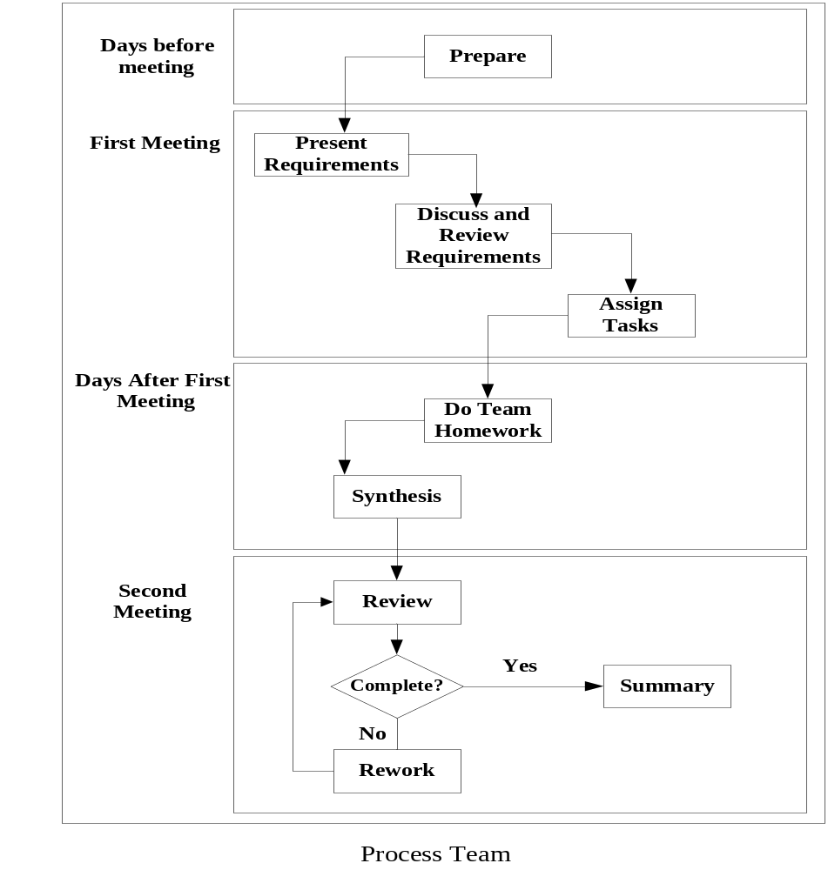
Steps | Description
Prepare | In first step, team member whom is assigned task to analysis team assignment title will preview problems in assignment.  Have to compose and delivery objects of meeting, problems need to discuss and tasks will give to each member in assignment.
Present requirement | Team member whom is assigned task to analysis team assignment title have to present the objects of meeting, problems and tasks to do for his/her team.
Discuss and review | Everybody in team will discuss the giving problems in previous step. Review objects of team assignment and tasks to do.  Everybody will modify objects and tasks to do together in this meeting after discussion.
Assign tasks | Team leader will assign works for each people.
Do Team homework | Team members will complete their works at home and send them to sub-leader.
Synthesis | Sub-leader will collect and integrated, preview final document and prepare to present.  Sub-leader sent final version to leader to pre-review.
Review | In this meeting, everybody will review and ensure assignment was finished. Documents were completed and check spelling errors.
Rework | If detect problems in documents, everybody will discuss and solve it in this meeting.
Summary | Team leader collect effort logs of people, get lessons learned together and improve process for next assignment.  After meeting, leader evaluate team members effort and submit.

Team roles and responsibility

Definition
Term | Definition
Role | A project role is an assignment on the project team
Responsibility | Project authority to take action, make decisions, and initiate action.

Defining and Assigning Project Roles and Responsibilities
Role | Responsibility | Name
The facilitator (constant) | - The facilitator is not a member of the team  - Owner of the overall business change that is being supported by team assignments  - Acts as resources to the team by intervening when necessary to keep the team on track | To Dinh Hieu
Leader (constant) | - Plan the project. This covers a multitude of activities (the degree to which the project manager personally plans the project will depend upon its scale. If there are three people in the project team the project manager can easily plan their work)  - Design project control mechanisms. How will you report progress, control change, manage risks,...? (every project is different, so need to design control and reporting mechanisms that suit your project)  - Manage project scope. If the scope is simply too big for the budget and timescale the project will fail  - Manage and report progress  - Be accountable for quality  - Reward and punish  - Define and get agreement to roles and assigns the activities for each of the team members  - Preparing the meeting agenda, including time, date, and location; and ensures the necessary resources are available for the meeting: for two meetings a week. If necessary, Team Leader can conduct the meeting on Friday for updating final of team assignment.  - Facilitate the team process, ensures that all members participate during the meetings, prevents other members from dominating, actively participates  - Ensures that team decisions are made by consensus where appropriate  - Monitor the statues and accomplishments of members, assuring timely completion of assignments: Prepare and after meeting. Oversees day-to-day operations.  - Review: effort log of each member and team assignment when it complete by members (.doc & .ppt)  - Evaluate the work of its members. | Le Thi Bich Van
Sub-Leader (this role will be change over the course of the project ) | - Participate as a team member  - Support Leader analysis of the main requirements and prepare an agenda for the meeting and post it on the team website. After the meeting has been conducted, the results of the meeting must be posted on the website.  - Present the documents for the team to review during the meeting and distribute them as minutes after the meeting in a timely manner  - Internal documentation and system documentation  - Provide resources  - Support Leader will have received completed parts of the assignment from other members of the team. He will then combine the whole Assignment and release (send it by email to all the members of the team and put it on the Team website) the draft of the assignment on Tuesday.  - Team will then comment on the whole assignment. It is a responsibility of the Team Leader to submit the Assignment on the due date of the assignment using the submission server at https://hoctructuyen.vanlanguni.edu.vn/course/view.php?id=343 | Le Dinh Thach Huyen (for week 1)
Members | - Estimate the work that will be assigned to them (in Effort log of members)  - Plan their own work (in Effort log of members)  - Record effort log every day and report status of their work  - Sign up to their task plan : Do teamwork, team member must complete their assigned works on time.  - Be accountable for the quality of their work  - Alert their team leader of problems and issues, ...  - Read documents before the first meeting every assignment  - Listens carefully and asks questions.  - Is enthusiastic-it’s contagious and helps galvanize the entire team.  - Understands and is committed to team objectives.  - Suggest improvements to the project plan, control processes, ...  - Gives honest, sincere appreciation. | Dang Huy Son  Do Minh Tam  Nguyen Trung Tin
Recorder (constant) | - Participate as a team member  - Integrate effort log every week  - Record meeting minutes every meeting | Do Minh Tam

Schedule
References attachment: “K15T1-Team11-Team Assignment1-Schedule.xls”.

